**Lab Example**:

Given: 4 S/C distributed in two orbital planes

S/C in same plane are 180 deg apart from each other

mission success requires visibility of 2 S/C from operational ground site

Find: develop a digital logic circuit that captures the conditions when the mission can/can’t be accomplished

Solve: let “1” represent a visible S/C

“0” represents a S/C that isn’t visible

look for truth table scenarios with 2 visible S/C, BUT

some scenarios are impossible (can’t see 2 S/C in the same orbit plane)

1. Complete the truth table
2. Create a logic statement
3. Simplify your logic statement

|  |  |  |  |  |
| --- | --- | --- | --- | --- |
| 1st Plane | | 2nd Plane | | Mission Success |
| A | B | C | D |
| 0 | 0 | 0 | 0 |  |
| 0 | 0 | 0 | 1 |  |
| 0 | 0 | 1 | 0 |  |
|  |  |  |  |  |
|  |  |  |  |  |
|  |  |  |  |  |
|  |  |  |  |  |
|  |  |  |  |  |
|  |  |  |  |  |
|  |  |  |  |  |
|  |  |  |  |  |
|  |  |  |  |  |
|  |  |  |  |  |
|  |  |  |  |  |
|  |  |  |  |  |
|  |  |  |  |  |

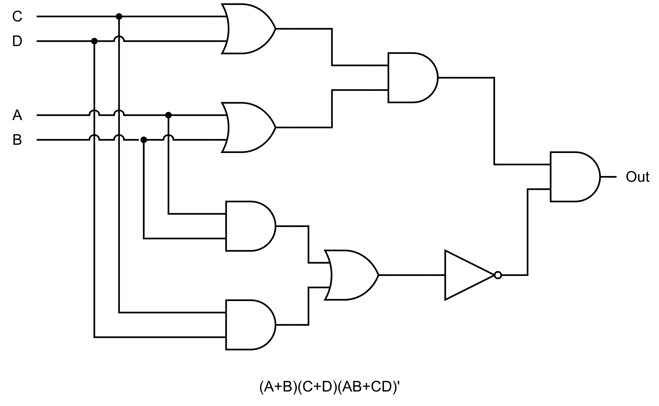

**Homework:**   
Using the laws and rules from the lesson notes, show that (A+B)(C+D)(AB+CD)' = (A’B+AB’)(C’D+CD’). Show every step, and list the law used for each step.